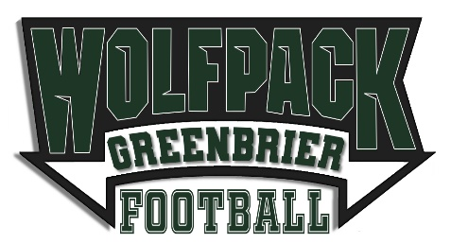
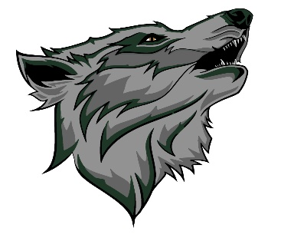
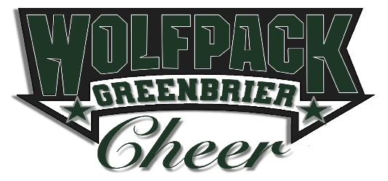

Show your Pack Pride and become a SPONSOR!
A Greenbrier Pop Warner Sponsorship is a great way to advertise your business!
Greenbrier Pop Warner is one of the largest youth associations in Georgia, with over 200 athletes from six local CSRA schools. As a league under National Pop Warner’s leadership, Greenbrier Pop Warner strives to instill core values such as teamwork, commitment, leadership and dedication. Sponsorship helps each and every child in our program succeed athletically, as well as scholastically. We had over 20 athletes qualify for the Pop Warner All-American scholar program due to their academic achievements last season. With your support we can continue our mission and provide opportunities for all youth to participate in competitive football and cheerleading. Your generous donation assists with the costs of:
- Purchase of new/additional safety and training equipment to help protect and teach athletes,
- Cheer and Football teams’ travel and fees to compete at the Southeast Regional and National competitions in Orlando, Florida, and
- Field rentals, insurance, and team fees.
With sponsorship help last year, we sent FOUR cheer teams and their families to the Southeast Regional Cheer Competition, in Orlando, Florida, and then to NATIONALS, also in Orlando! Additionally, we purchased an additional Automated External Defibrillator (AED) and provided our local schools support for their use of fields. We cannot thank you enough for your support and for donating to our organization!
Sponsorship Levels for 2022
$250 Supporter Club – Your business logo displayed on our Social Media pages and Website in rotation with other sponsors.
$500 End Zone Club – The SUPPORTER Club plus linking your business webpage to our Website, announcing your company during each Greenbrier Pop Warner game played at Greenbrier High School (GHS), and your Business Logo placed on the back of our team shirts.
$1,000 Wolfpack Club – The SUPPORTER and END ZONE Clubs plus a private tent in the stands and a $20 concessions gift card during home games. Free registration for one athlete.
$1,500 Ultimate Greenbrier Fan Club – All previous packages included plus your company logo displayed on a banner (supplied by GPW) during each Greenbrier Pop Warner game played at GHS. Cooling towels with your company logo will be provided to players. Additionally, your company can host a booth (near concessions) at Greenbrier Pop Warner Games played at GHS. (This will be located near the entrance of the stadium and will be weather dependent. Your company will provide equipment, documents, supplies required for the booth. Greenbrier Pop Warner will designate a location and give assistance for the set up/tear down.)
Please let us know if we can provide you with additional information. Email: gpwsponsorship2021@gmail.com or vicepresident.gpw@gmail.com. Go Wolfpack!
Greenbrier Pop Warner 9044 Winterton Street Evans Georgia 30809 (404) 934-5749

Greenbrier Pop Warner is a Non-Profit Organization
Greenbrier Pop Warner Donation Receipt

Date:
Company Name:
Company Address:

Company Contact:
Company Phone:
Email:

TIN : 45-4671202

Dear:

On behalf of the Greenbrier Pop Warner Association (GPW), this certificate has been issued to the above-named company for their generous donation of:

Dollar Value:

Through your support and generosity, we are able to continue the GPW mission. On behalf of all of the volunteers and athletes associated with GPW, we thank you.

Sincerely,

Acceptor Name:
GPW Title:
Signature:

Greenbrier Pop Warner 9044 Winterton Street Evans Georgia 30809. (404) 934-5749
Greenbrier Pop Warner is a Non-Profit Organization

